Module: Get Started With Apex triggers



trigger AccountAddressTrigger on Account (before insert, before update) {

for(Account account:Trigger.New){

if(account.Match_Billing_Address__c == True){

account.ShippingPostalCode = account.BillingPostalCode;

}

}

}

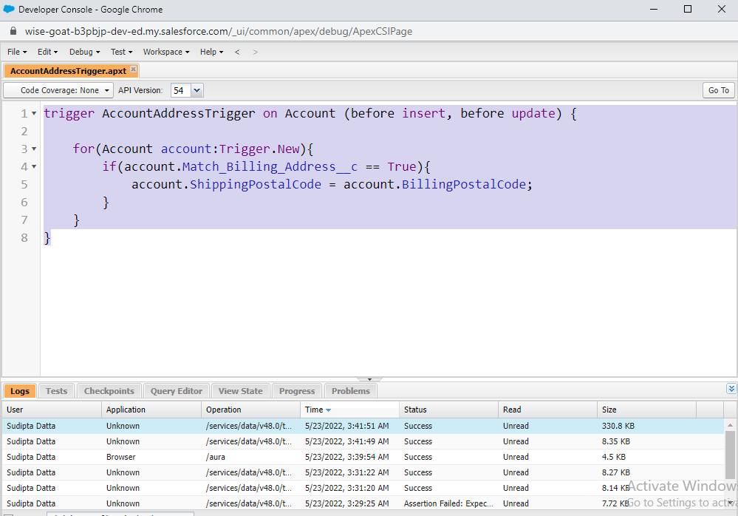

Module:Apex Testing: Bulk Apex Triggers



trigger ClosedOpportunityTrigger on Opportunity (after insert, after update) {

List<Task> tasklist = new List<Task>();

for(Opportunity opp: Trigger.New){

if(opp.StageName == 'Closed Won'){

tasklist.add(new Task(Subject = 'Follow Up Test Task', WhatId = opp.Id));

}

}

if(tasklist.size()>0){

insert tasklist;

}

}

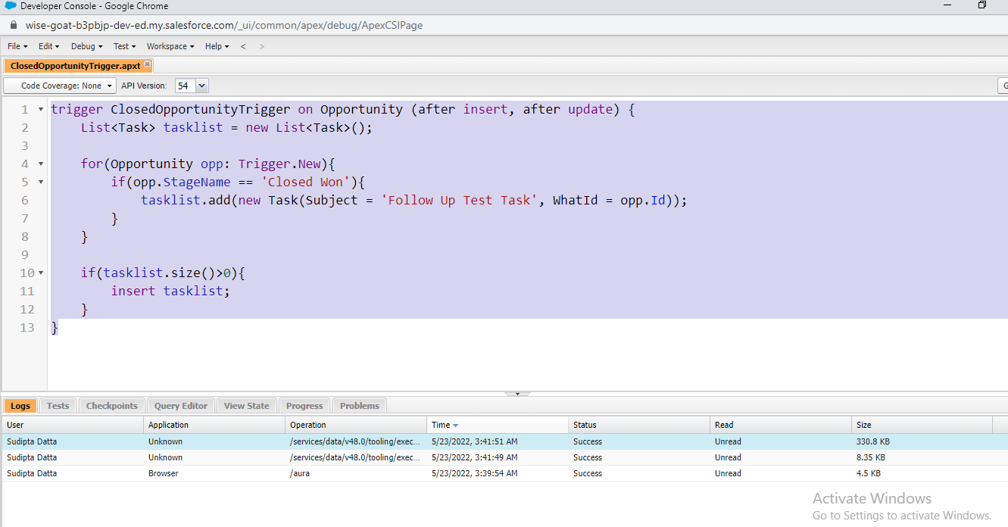

Module:Get Started With Apex Unit Tests



public class VerifyDate {

//method to handle potential checks against two dates

public static Date CheckDates(Date date1, Date date2) {

//if date2 is within the next 30 days of date1, use date2. Otherwise use the end of the month

if(DateWithin30Days(date1,date2)) {

return date2;

} else {

return SetEndOfMonthDate(date1);

}

}

//method to check if date2 is within the next 30 days of date1

@TestVisible private static Boolean DateWithin30Days(Date date1, Date date2) {

//check for date2 being in the past

if( date2 < date1) { return false; }

//check that date2 is within (>=) 30 days of date1

Date date30Days = date1.addDays(30); //create a date 30 days away from date1

if( date2 >= date30Days ) { return false; }

else { return true; }

}

//method to return the end of the month of a given date

@TestVisible private static Date SetEndOfMonthDate(Date date1) {

Integer totalDays = Date.daysInMonth(date1.year(), date1.month());

Date lastDay = Date.newInstance(date1.year(), date1.month(), totalDays);

return lastDay;

}

}



@isTest

private class TestVerifyDate {

@isTest static void Test_CheckDates_case1(){

Date D = VerifyDate.CheckDates(date.parse('01/01/2020'), date.parse('01/05/2020'));

System.assertEquals(date.parse('01/05/2020'), D);

}

@isTest static void Test_CheckDates_case2(){

Date D = VerifyDate.CheckDates(date.parse('01/01/2020'), date.parse('05/05/2020'));

System.assertEquals(date.parse('01/31/2020'), D);

}

@isTest static void Test_DateWithin30Days_case1(){

Boolean flag = VerifyDate.DateWithin30Days(date.parse('01/01/2020'), date.parse('12/30/2019'));

System.assertEquals(false, flag);

}

@isTest static void Test_DateWithin30Days_case2(){

Boolean flag = VerifyDate.DateWithin30Days(date.parse('01/01/2020'), date.parse('02/02/2020'));

System.assertEquals(false, flag);

}

@isTest static void Test_DateWithin30Days_case3(){

Boolean flag = VerifyDate.DateWithin30Days(date.parse('01/01/2020'), date.parse('01/15/2020'));

System.assertEquals(false, flag);

}

@isTest static void Test_SetEndOfMonthDate(){

Date returndate = VerifyDate.SetEndOfMonthDate(date.parse('01/01/2020'));

}

}

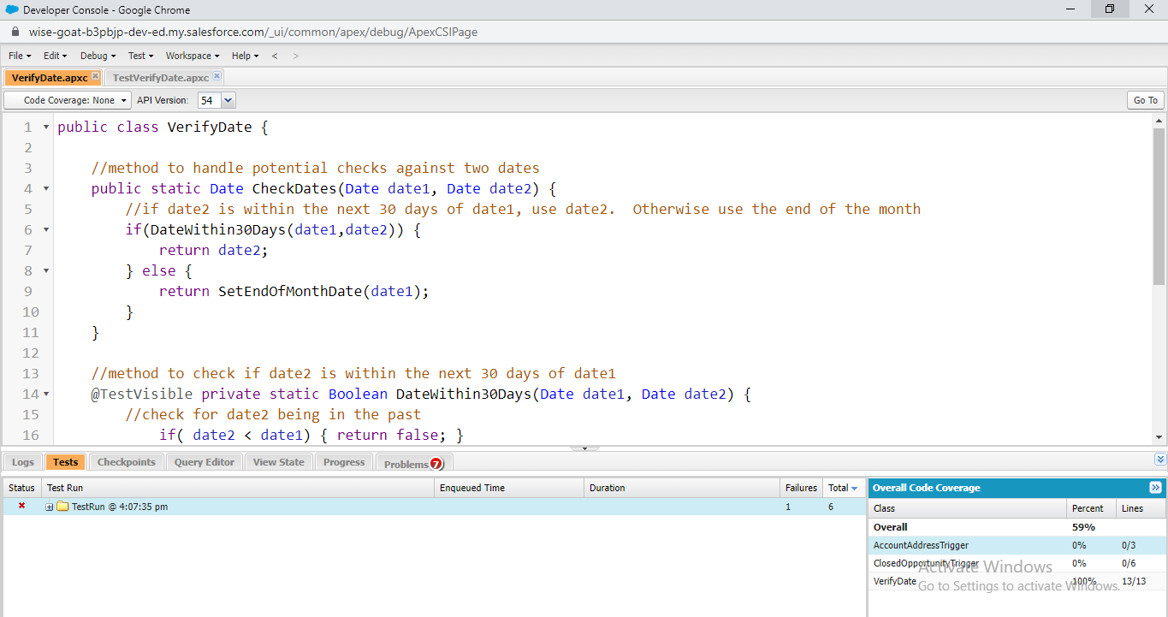

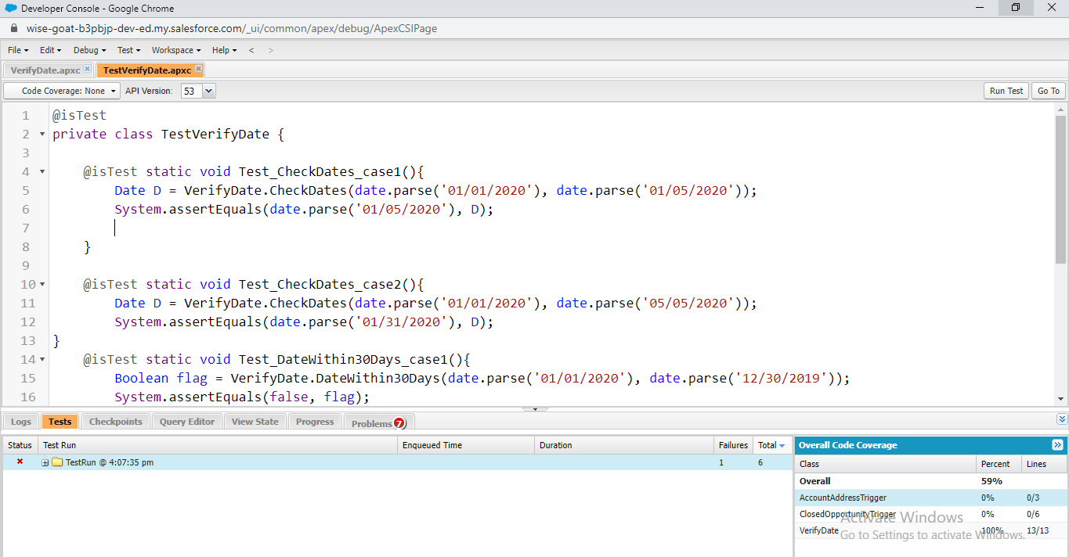

Module: Test Apex Triggers



trigger RestrictContactByName on Contact (before insert, before update) {

//check contacts prior to insert or update for invalid data

For (Contact c : Trigger.New) {

if(c.LastName == 'INVALIDNAME') { //invalidname is invalid

c.AddError('The Last Name "'+c.LastName+'" is not allowed for DML');

}

}

}



@isTest

public class TestRestrictContactByName {

@isTest static void Test_insertupdateContact(){

Contact cnt = new Contact();

cnt.LastName = 'INVALIDNAME';

Test.startTest();

Database.SaveResult result = Database.insert(cnt, false);

Test.stopTest();

System.assert(!result.isSuccess());

System.assert(result.getErrors().size() > 0);

System.assertEquals('The Last Name "INVALIDNAME" is not allowded for DML',result.getErrors()[0].getmessage());

}

}

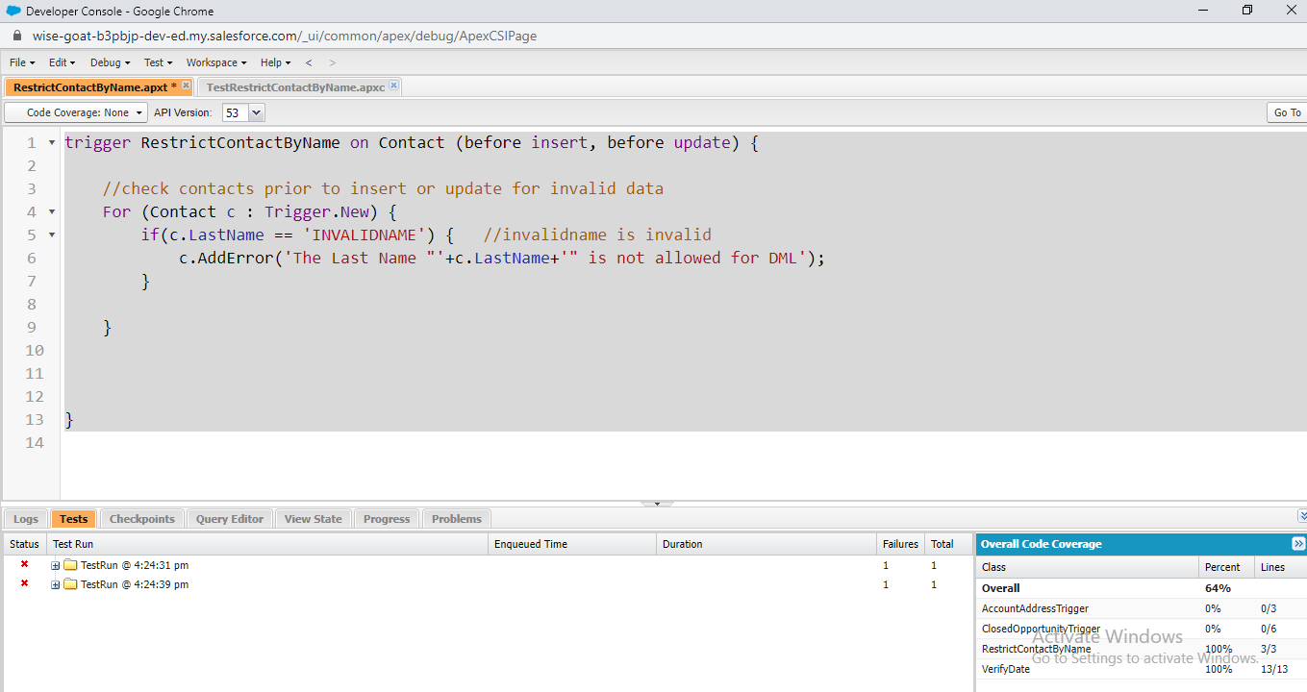

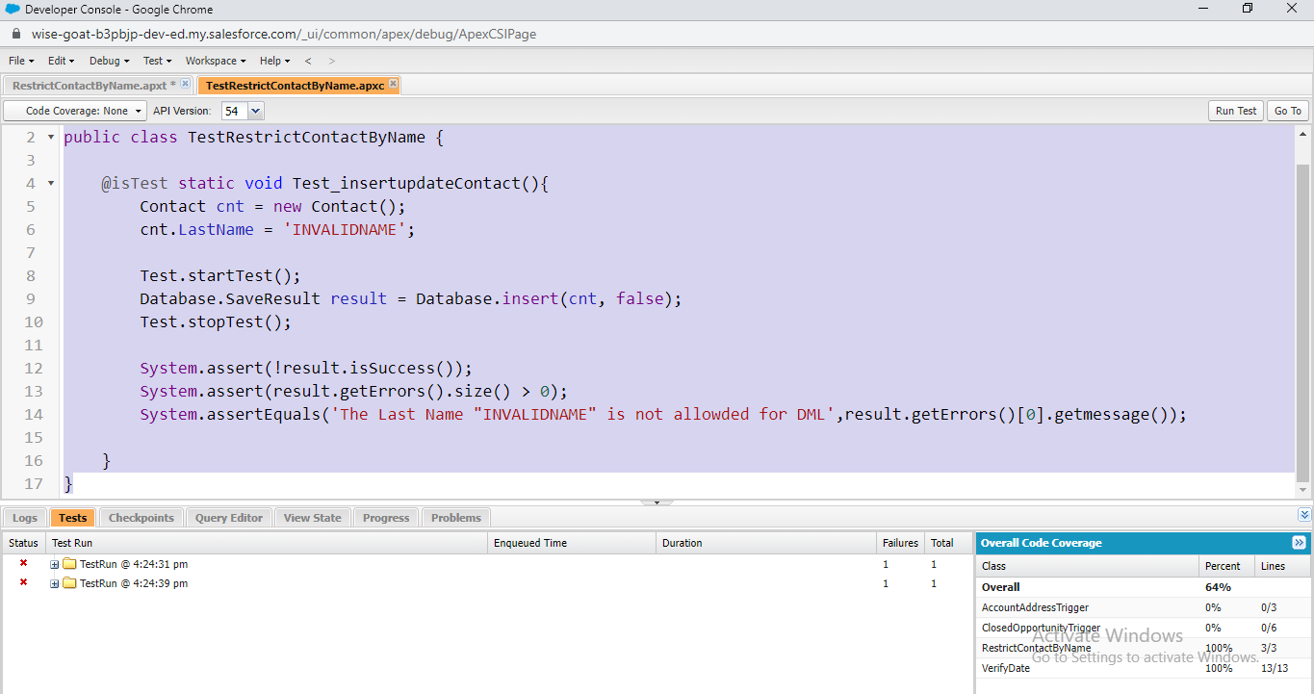

Module: Create Test Data for Apex Tests

public class RandomContactFactory {

public static List<Contact> generateRandomContacts(Integer numcnt, string lastname){

List<Contact> contacts = new List<Contact> ();

for(Integer i=0;i<numcnt;i++){

Contact cnt = new Contact(FirstName = 'Test '+i, LastName = lastname);

contacts.add(cnt);

}

return contacts;

}

}

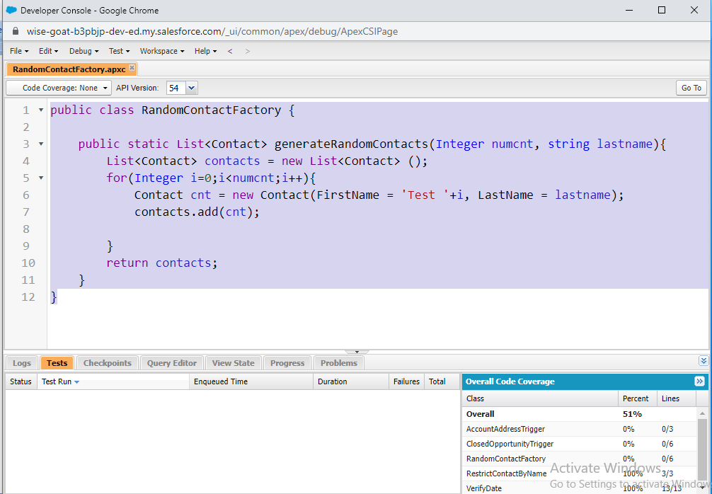

[**Asynchronous Apex**](https://trailhead.salesforce.com/content/learn/modules/asynchronous_apex)**>**[**Use Future Methods**](javascript:void(0))



public class AccountProcessor {

@future

public static void countContacts(List<Id> accountIds){

List<Account> accountsToUpdate = new List<Account>();

List<Account> accounts = [Select Id, Name, (Select Id from Contacts) from Account Where Id in :accountIds];

for(Account acc:accounts){

List<Contact> contactList = acc.Contacts;

acc.Number_Of_Contacts__c = contactList.size();

accountsToUpdate.add(acc);

}

update accountsToUpdate;

}

}

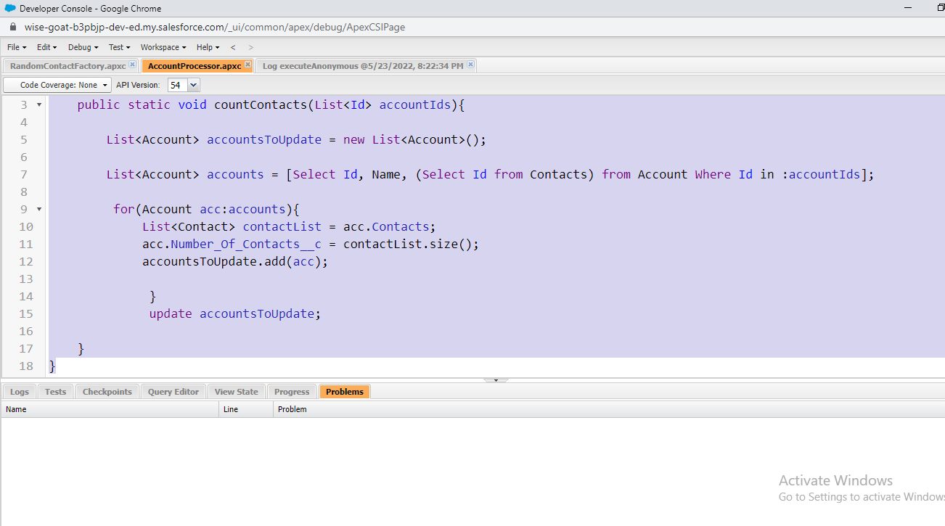

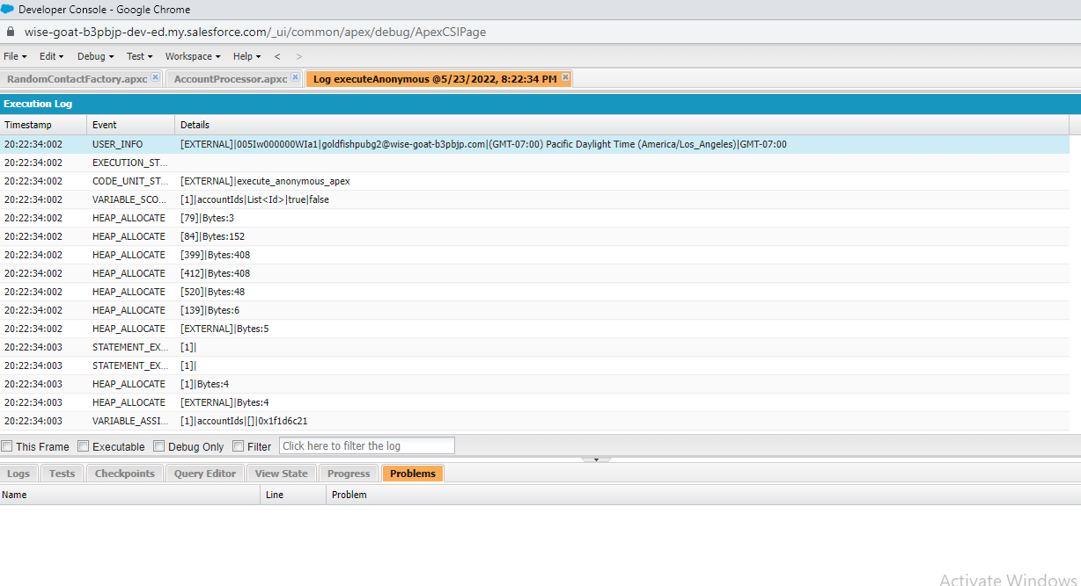



@IsTest

private static void testCountContacts(){

Account newAccount = new Account(Name='Test Account');

insert newAccount;

Contact newContact1 = new Contact(FirstName='John',LastName='Doe',AccountId = newAccount.Id);

insert newContact1;

Contact newContact2 = new Contact(FirstName='Jane',LastName='Doe',AccountId = newAccount.Id);

insert newContact2;

List<Id> AccountIds = new List<Id>();

accountIds.add(newAccount.Id);

Test.startTest();

AccountProcessor.countContacts(accountIds);

Test.stopTest();

}

}

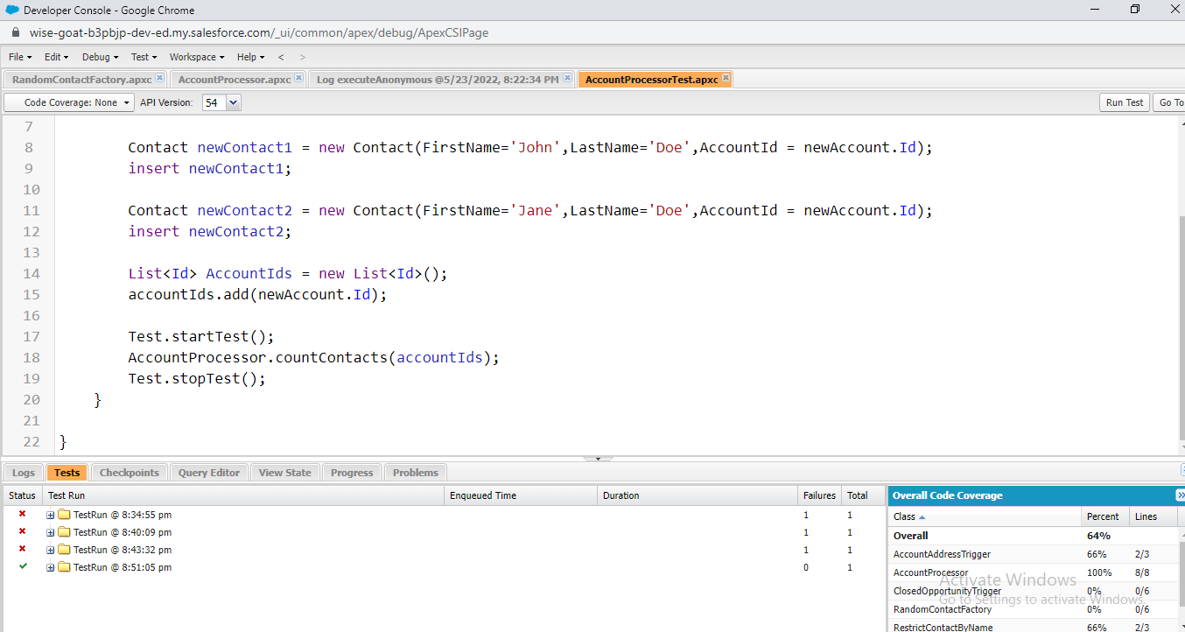

**Module:Use Batch Apex**



global class LeadProcessor implements Database.Batchable<sObject> {

global integer count = 0;

global Database.QueryLocator start(Database.BatchableContext bc){

return Database.getQueryLocator('SELECT ID, LeadSource FROM Lead');

}

global void execute(Database.BatchableContext bc, List<Lead> L_list){

List<Lead> L_list_new = new List<lead>();

for(lead L:L_list){

L.leadsource = 'Dreamforce';

L_list_new.add(L);

count += 1;

}

update L_list_new;

}

global void finish(Database.BatchableContext bc){

system.debug('count = ' + count);

}

}



@isTest

public class LeadProcessorTest {

@isTest

public static void testit(){

List<lead> L_list = new List<Lead>();

for(Integer i=0; i<200; i++){

Lead L = new lead();

L.LastName = 'name' + i;

L.Company ='Company';

L.Status = 'Random Status';

L_list.add(L);

}

insert L_list;

Test.startTest();

LeadProcessor lp = new LeadProcessor();

Id batchId = Database.executeBatch(lp);

Test.stopTest();

}

}

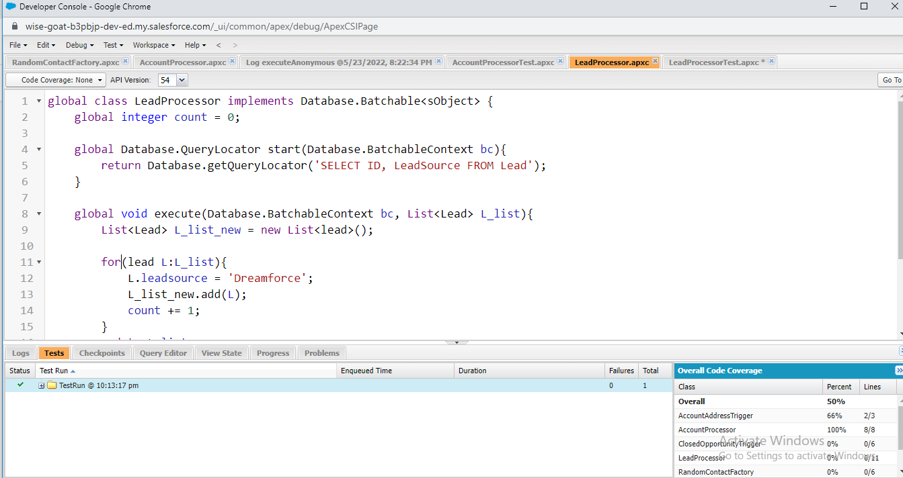

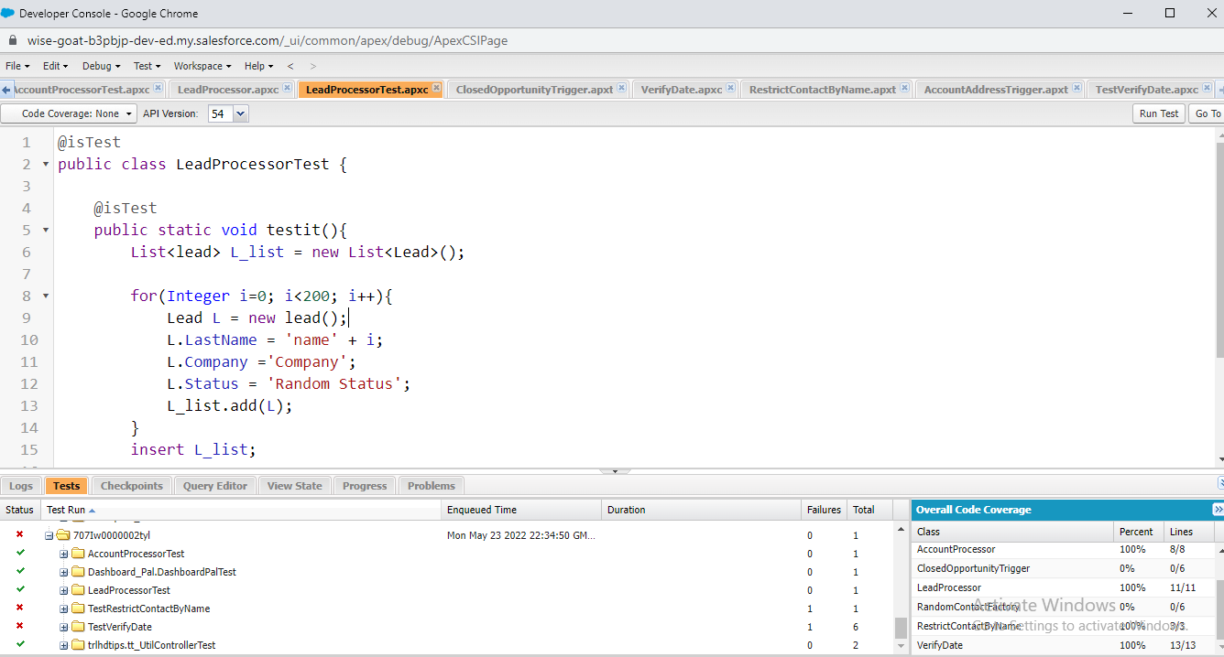

# Module: Control Processes with Queueable Apex



public class AddPrimaryContact implements Queueable{

private Contact con;

private String state;

public AddPrimaryContact(Contact con, String state){

this.con = con;

this.state = state;

}

public void execute(QueueableContext context){

List<Account> accounts = [Select Id, Name, (Select FirstName, Id from contacts)

from Account where BillingState = :state Limit 200];

List<Contact> primaryContacts = new List<Contact>();

for(Account acc:accounts){

contact c = con.clone();

c.AccountId = acc.Id;

primaryContacts.add(c);

}

if(primaryContacts.size() > 0){

insert primaryContacts;

}

}

}



@isTest

public class AddPrimaryContactTest {

static testmethod void testQueueable(){

List<Account> testAccounts = new List<Account>();

for(Integer i=0;i<50;i++){

testAccounts.add(new Account(Name='Account '+i,BillingState='CA'));

}

for(Integer j=0;j<50;j++){

testAccounts.add(new Account(Name='Account '+j,BillingState='NY'));

}

insert testAccounts;

Contact testContact = new Contact(FirstName = 'John', LastName = 'Doe');

insert testContact;

AddPrimaryContact addit = new addPrimaryContact(testContact, 'CA');

Test.startTest();

system.enqueueJob(addit);

Test.stopTest();

System.assertEquals(50,[Select count() from Contact where accountId in (Select Id from Account where BillingState='CA')]);

}

}

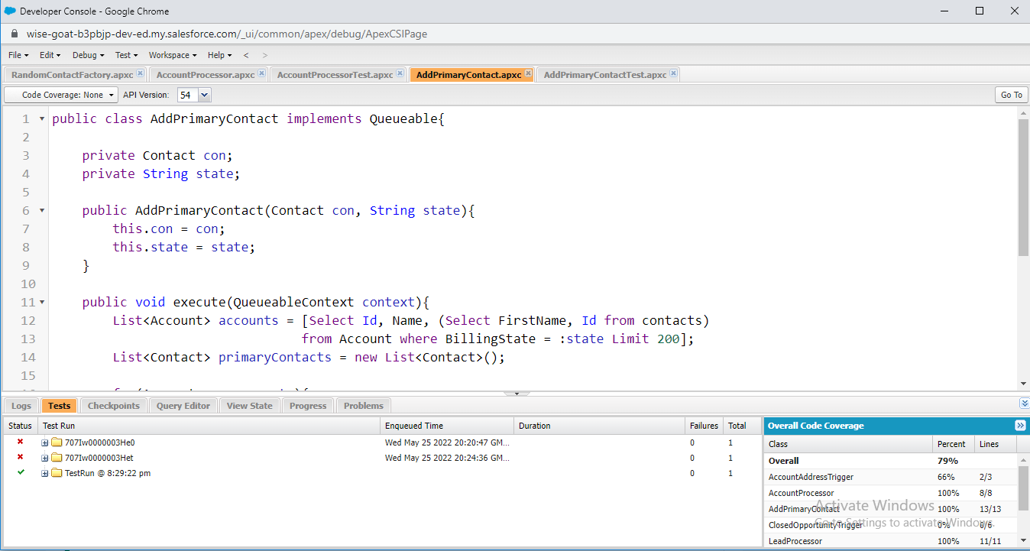

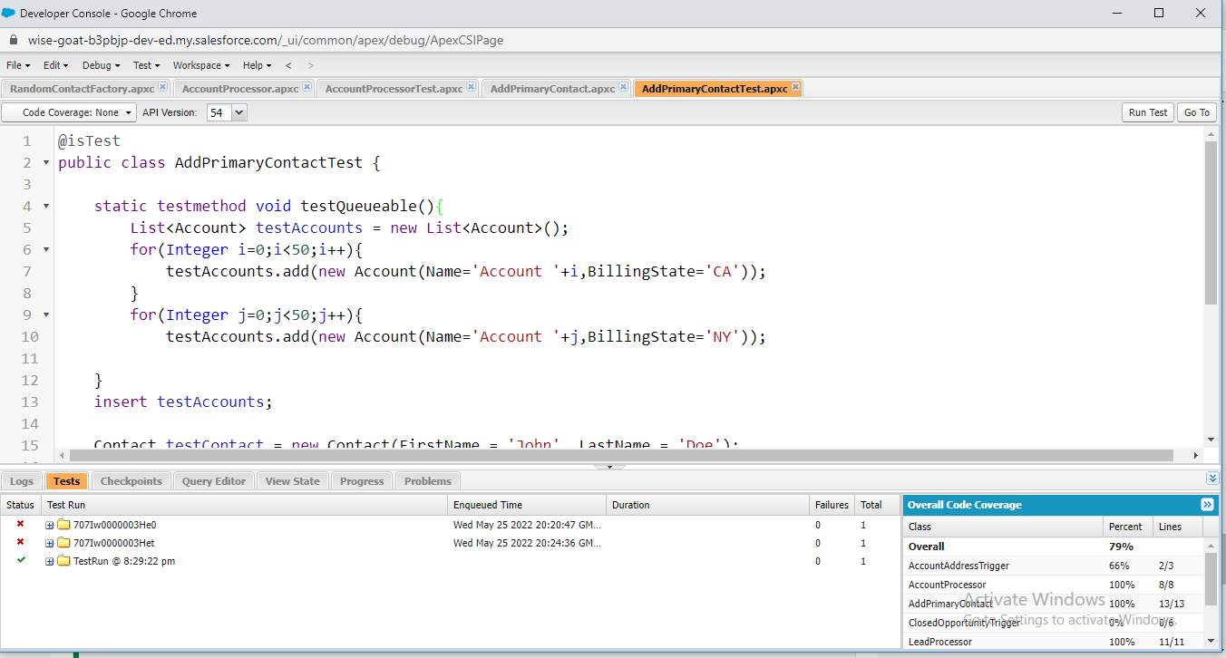

Module: [Apex Integration Services](https://trailhead.salesforce.com/content/learn/modules/apex_integration_services)

Apex Integration Overview



global class DailyLeadProcessor implements Schedulable{

global void execute(SchedulableContext ctx){

List<lead> leadstoupdate = new List<lead>();

List<Lead> leads = [Select id From Lead Where LeadSource = Null Limit 200];

for(Lead l:leads){

l.LeadSource = 'DreamForce';

leadstoupdate.add(l);

}

update leadstoupdate;

}

}



@isTest

private class DailyLeadProcessorTest {

public static String CRON_EXP = '0 0 0 15 3 ? 2023';

static testmethod void testScheduledJob(){

List<lead> leads = new List<lead>();

for (Integer i=0; i<200; i++){

Lead l = new Lead(

FirstName = 'First ' + i,

LastName = 'LastName',

Company = 'The Inc'

);

leads.add(l);

}

insert leads;

Test.startTest();

String jobId = System.schedule('ScheduledApexTest',CRON_EXP,new DailyLeadProcessor());

Test.stopTest();

List<Lead> checkleads = new List<Lead>();

checkleads = [Select Id From Lead Where LeadSource = 'Dreamforce' and Company = 'The Inc'];

System.assertEquals(200, checkleads.size(), 'Leads were not created');

}

}

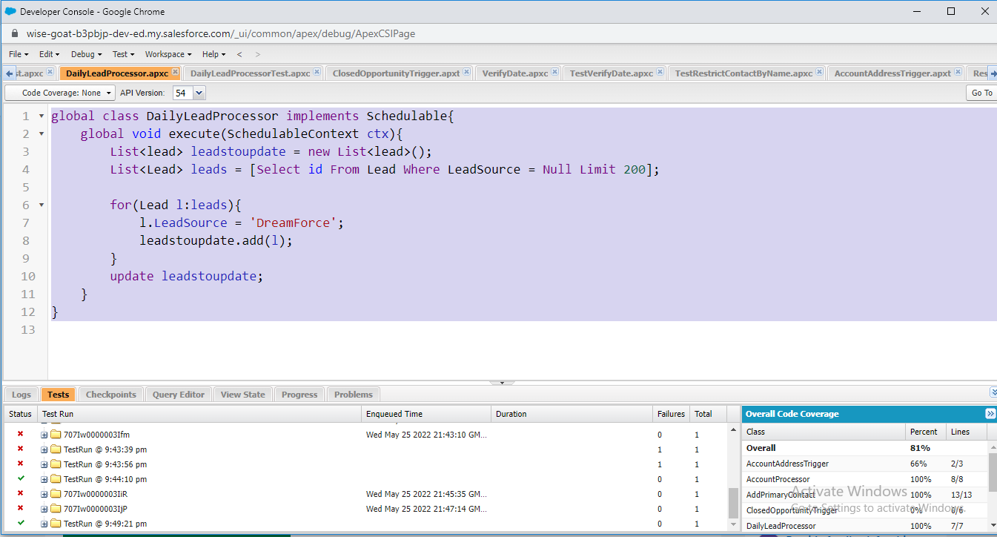

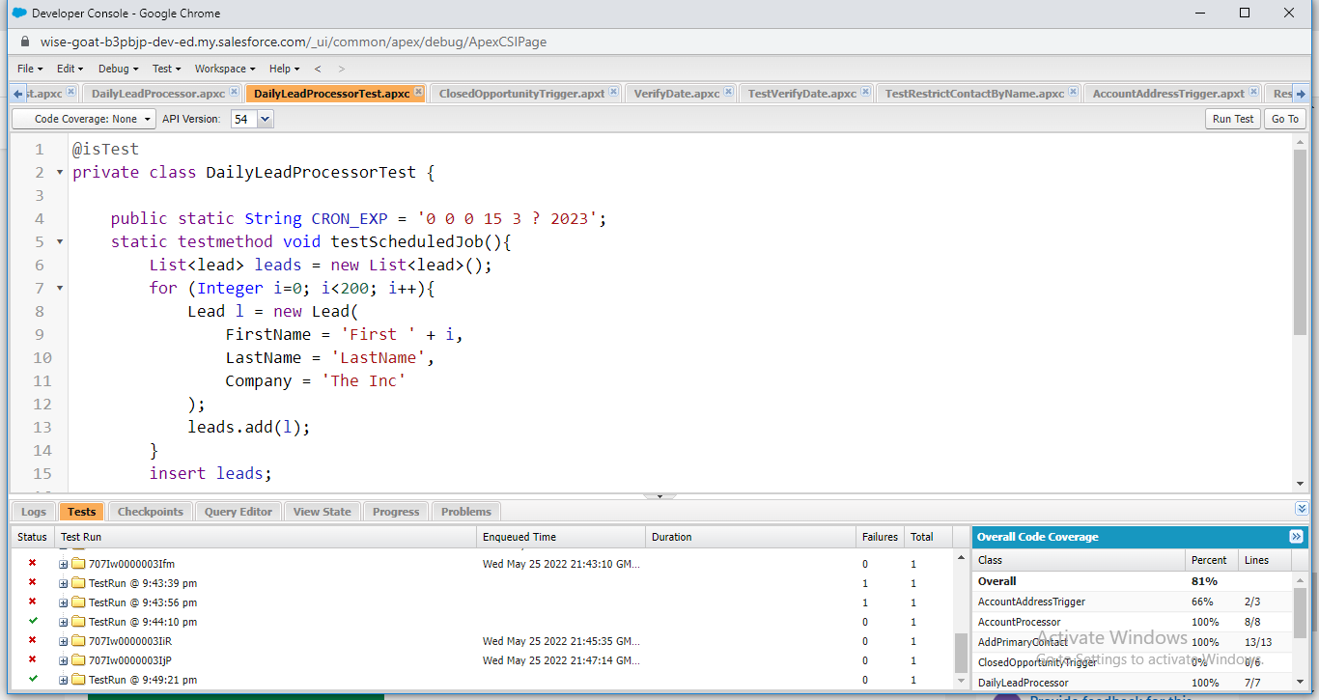

Apex REST Callouts



public class AnimalLocator{

public static String getAnimalNameById(Integer x){

Http http = new Http();

HttpRequest req = new HttpRequest();

req.setEndpoint('https://th-apex-http-callout.herokuapp.com/animals/' + x);

req.setMethod('GET');

Map<String, Object> animal= new Map<String, Object>();

HttpResponse res = http.send(req);

if (res.getStatusCode() == 200) {

Map<String, Object> results = (Map<String, Object>)JSON.deserializeUntyped(res.getBody());

animal = (Map<String, Object>) results.get('animal');

}

return (String)animal.get('name');

}

}



@isTest

private class AnimalLocatorTest{

@isTest static void AnimalLocatorMock1() {

Test.setMock(HttpCalloutMock.class, new AnimalLocatorMock());

string result = AnimalLocator.getAnimalNameById(3);

String expectedResult = 'chicken';

System.assertEquals(result,expectedResult );

}

}



@isTest

private class AnimalLocatorTest{

@isTest static void AnimalLocatorMock1() {

Test.setMock(HttpCalloutMock.class, new AnimalLocatorMock());

string result = AnimalLocator.getAnimalNameById(3);

String expectedResult = 'chicken';

System.assertEquals(result,expectedResult );

}

}

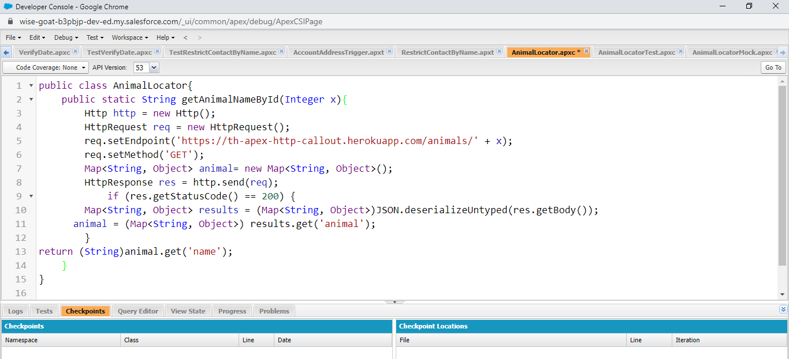

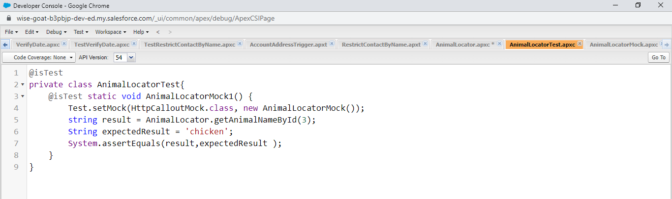

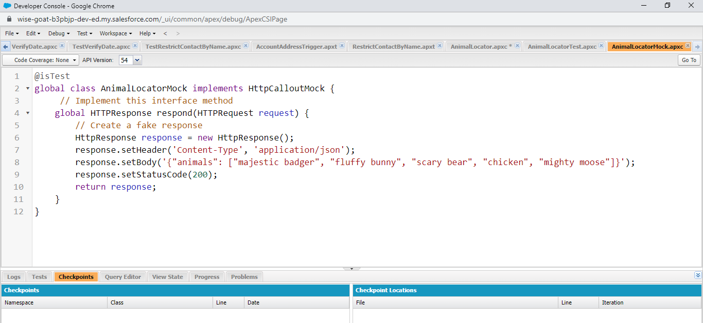

[Apex Integration Services](https://trailhead.salesforce.com/content/learn/modules/apex_integration_services)

[**Apex SOAP Callouts**](javascript:void(0))



public class ParkLocator {

public static string[] country(string theCountry) {

ParkService.ParksImplPort parkSvc = new ParkService.ParksImplPort(); // remove space

return parkSvc.byCountry(theCountry);

}

}

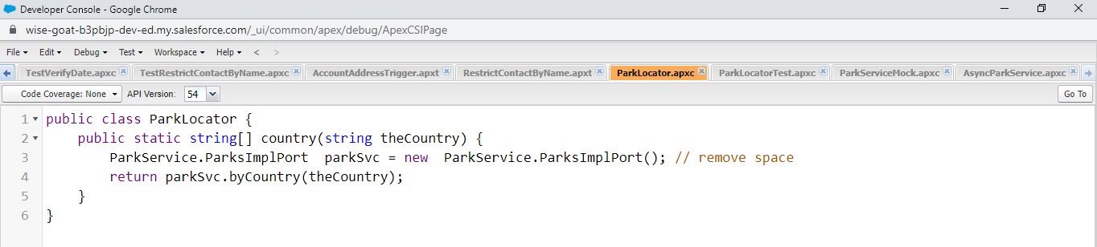



@isTest

private class ParkLocatorTest {

@isTest static void testCallout() {

Test.setMock(WebServiceMock.class, new ParkServiceMock ());

String country = 'United States';

List<String> result = ParkLocator.country(country);

List<String> parks = new List<String>{'Yellowstone', 'Mackinac National Park', 'Yosemite'};

System.assertEquals(parks, result);

}

}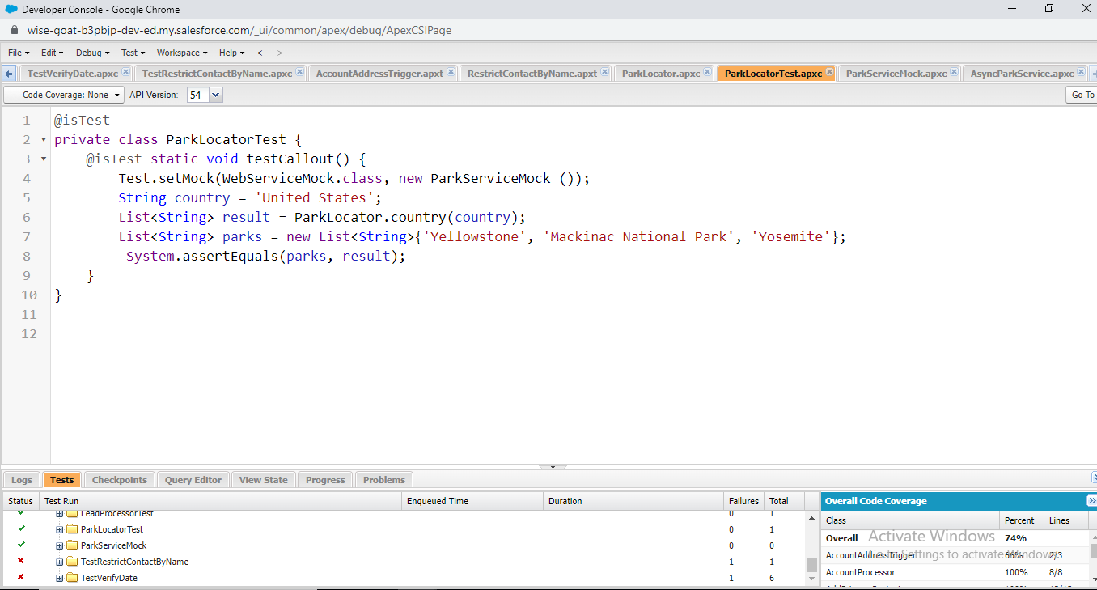



@isTest

global class ParkServiceMock implements WebServiceMock {

global void doInvoke(

Object stub,

Object request,

Map<String, Object> response,

String endpoint,

String soapAction,

String requestName,

String responseNS,

String responseName,

String responseType) {

// start - specify the response you want to send

ParkService.byCountryResponse response_x = new ParkService.byCountryResponse();

response_x.return_x = new List<String>{'Yellowstone', 'Mackinac National Park', 'Yosemite'};

// end

response.put('response_x', response_x);

}

}

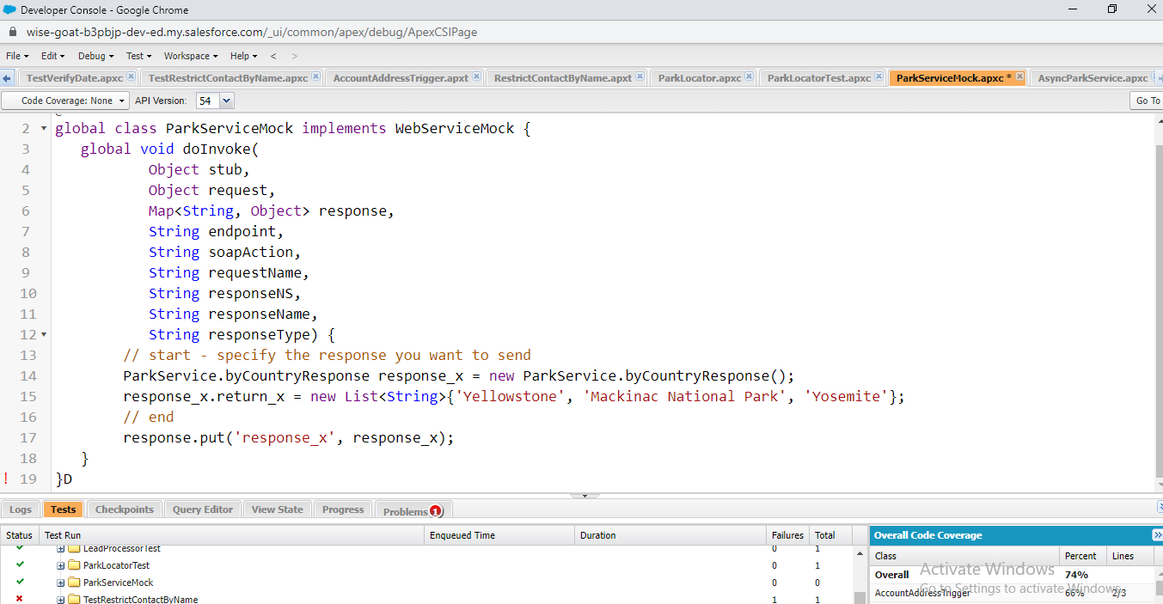



//Generated by wsdl2apex

public class AsyncParkService {

public class byCountryResponseFuture extends System.WebServiceCalloutFuture {

public String[] getValue() {

ParkService.byCountryResponse response = (ParkService.byCountryResponse)System.WebServiceCallout.endInvoke(this);

return response.return_x;

}

}

public class AsyncParksImplPort {

public String endpoint_x = 'https://th-apex-soap-service.herokuapp.com/service/parks';

public Map<String,String> inputHttpHeaders_x;

public String clientCertName_x;

public Integer timeout_x;

private String[] ns_map_type_info = new String[]{'http://parks.services/', 'ParkService'};

public AsyncParkService.byCountryResponseFuture beginByCountry(System.Continuation continuation,String arg0) {

ParkService.byCountry request_x = new ParkService.byCountry();

request_x.arg0 = arg0;

return (AsyncParkService.byCountryResponseFuture) System.WebServiceCallout.beginInvoke(

this,

request_x,

AsyncParkService.byCountryResponseFuture.class,

continuation,

new String[]{endpoint_x,

'',

'http://parks.services/',

'byCountry',

'http://parks.services/',

'byCountryResponse',

'ParkService.byCountryResponse'}

);

}

}

}

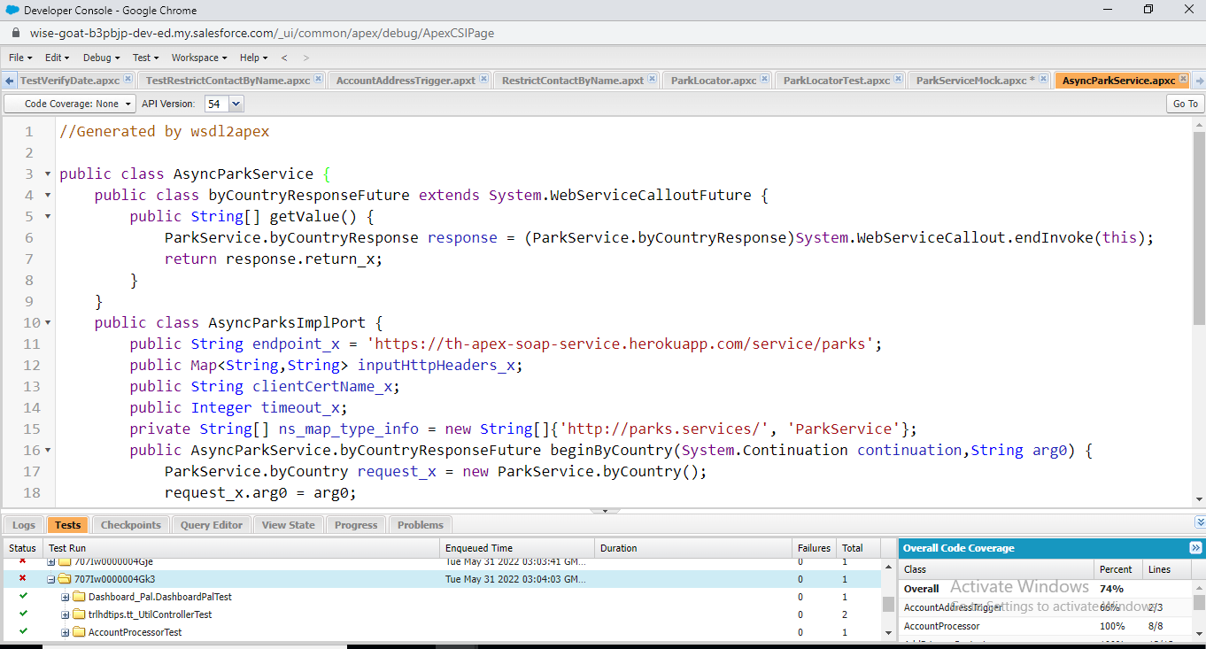

[Apex Integration Services](https://trailhead.salesforce.com/content/learn/modules/apex_integration_services)

[**Apex Web Services**](javascript:void(0))



@RestResource(urlMapping='/Accounts/*/contacts')

global class AccountManager {

@HttpGet

global static Account getAccount() {

RestRequest req = RestContext.request;

String accId = req.requestURI.substringBetween('Accounts/', '/contacts');

Account acc = [SELECT Id, Name, (SELECT Id, Name FROM Contacts)

FROM Account WHERE Id = :accId];

return acc;

}

}

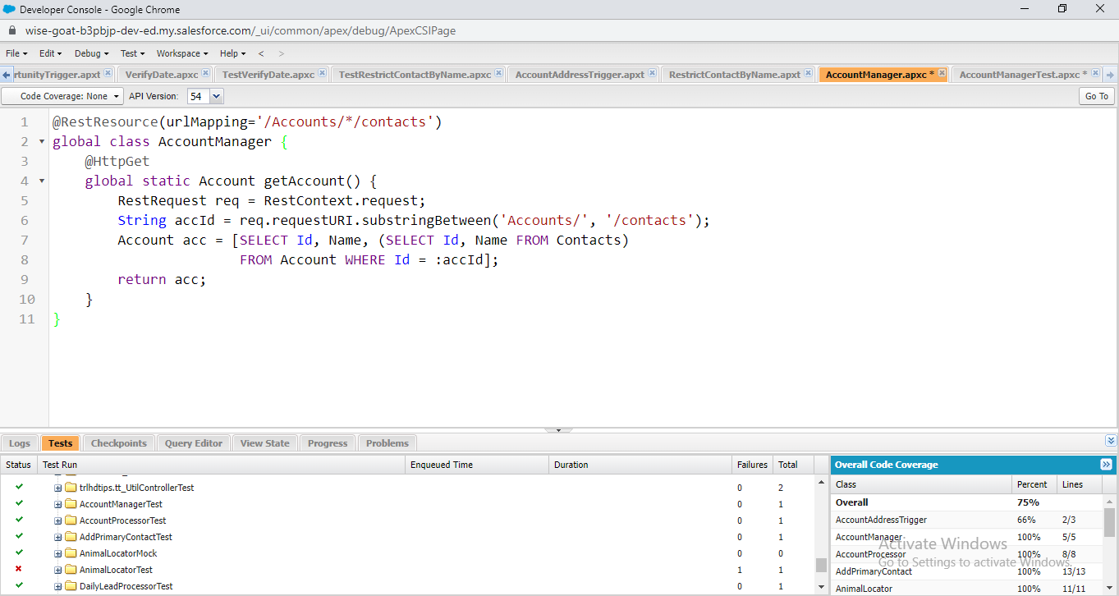



@isTest

private class AccountManagerTest {

private static testMethod void getAccountTest1() {

Id recordId = createTestRecord();

// Set up a test request

RestRequest request = new RestRequest();

request.requestUri = 'https://na1.salesforce.com/services/apexrest/Accounts/'+ recordId +'/contacts' ;

request.httpMethod = 'GET';

RestContext.request = request;

// Call the method to test

Account thisAccount = AccountManager.getAccount();

// Verify results

System.assert(thisAccount != null);

System.assertEquals('Test record', thisAccount.Name);

}

// Helper method

static Id createTestRecord() {

// Create test record

Account TestAcc = new Account(

Name='Test record');

insert TestAcc;

Contact TestCon= new Contact(

LastName='Test',

AccountId = TestAcc.id);

return TestAcc.Id;

}

}

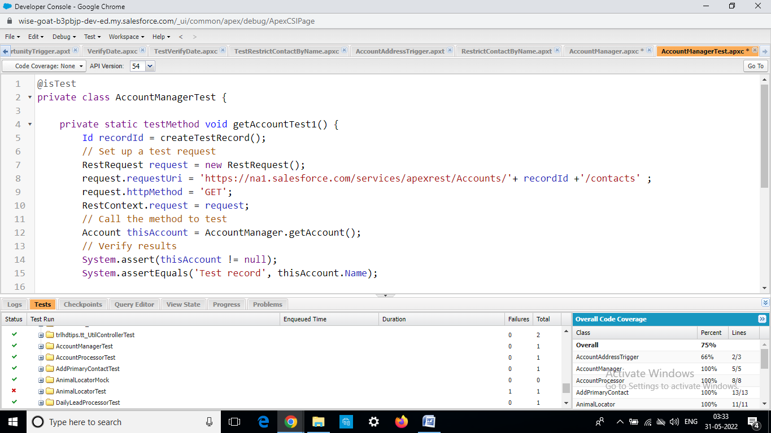

**SUPERBADGE:APEX SPECIALIST**

**Step2: Automate record creation**



public with sharing class MaintenanceRequestHelper {

public static void updateworkOrders(List<Case> updWorkOrders, Map<Id,Case> nonUpdCaseMap) {

Set<Id> validIds = new Set<Id>();

For (Case c : updWorkOrders){

if (nonUpdCaseMap.get(c.Id).Status != 'Closed' && c.Status == 'Closed'){

if (c.Type == 'Repair' || c.Type == 'Routine Maintenance'){

validIds.add(c.Id);

}

}

}

if (!validIds.isEmpty()){

List<Case> newCases = new List<Case>();

Map<Id,Case> closedCasesM = new Map<Id,Case>([SELECT Id, Vehicle__c, Equipment__c, Equipment__r.Maintenance_Cycle__c,(SELECT Id,Equipment__c,Quantity__c FROM Equipment_Maintenance_Items__r)

FROM Case WHERE Id IN :validIds]);

Map<Id,Decimal> maintenanceCycles = new Map<ID,Decimal>();

AggregateResult[] results = [SELECT Maintenance_Request__c, MIN(Equipment__r.Maintenance_Cycle__c)cycle FROM Equipment_Maintenance_Item__c WHERE Maintenance_Request__c IN :ValidIds GROUP BY Maintenance_Request__c];

for (AggregateResult ar : results){

maintenanceCycles.put((Id) ar.get('Maintenance_Request__c'), (Decimal) ar.get('cycle'));

}

for(Case cc : closedCasesM.values()){

Case nc = new Case (

ParentId = cc.Id,

Status = 'New',

Subject = 'Routine Maintenance',

Type = 'Routine Maintenance',

Vehicle__c = cc.Vehicle__c,

Equipment__c =cc.Equipment__c,

Origin = 'Web',

Date_Reported__c = Date.Today()

);

If (maintenanceCycles.containskey(cc.Id)){

nc.Date_Due__c = Date.today().addDays((Integer) maintenanceCycles.get(cc.Id));

} else {

nc.Date_Due__c = Date.today().addDays((Integer) cc.Equipment__r.maintenance_Cycle__c);

}

newCases.add(nc);

}

insert newCases;

List<Equipment_Maintenance_Item__c> clonedWPs = new List<Equipment_Maintenance_Item__c>();

for (Case nc : newCases){

for (Equipment_Maintenance_Item__c wp : closedCasesM.get(nc.ParentId).Equipment_Maintenance_Items__r){

Equipment_Maintenance_Item__c wpClone = wp.clone();

wpClone.Maintenance_Request__c = nc.Id;

ClonedWPs.add(wpClone);

}

}

insert ClonedWPs;

}

}

}



trigger MaintenanceRequest on Case (before update, after update) {

if(Trigger.isUpdate && Trigger.isAfter){

MaintenanceRequestHelper.updateWorkOrders(Trigger.New, Trigger.OldMap);

}

}

**Step3: Synchronize Salesforce data with an external system**



public with sharing class WarehouseCalloutService implements Queueable {

private static final String WAREHOUSE_URL = 'https://th-superbadge-apex.herokuapp.com/equipment';

//class that makes a REST callout to an external warehouse system to get a list of equipment that needs to be updated.

//The callout’s JSON response returns the equipment records that you upsert in Salesforce.

@future(callout=true)

public static void runWarehouseEquipmentSync(){

Http http = new Http();

HttpRequest request = new HttpRequest();

request.setEndpoint(WAREHOUSE_URL);

request.setMethod('GET');

HttpResponse response = http.send(request);

List<Product2> warehouseEq = new List<Product2>();

if (response.getStatusCode() == 200){

List<Object> jsonResponse = (List<Object>)JSON.deserializeUntyped(response.getBody());

System.debug(response.getBody());

//class maps the following fields: replacement part (always true), cost, current inventory, lifespan, maintenance cycle, and warehouse SKU

//warehouse SKU will be external ID for identifying which equipment records to update within Salesforce

for (Object eq : jsonResponse){

Map<String,Object> mapJson = (Map<String,Object>)eq;

Product2 myEq = new Product2();

myEq.Replacement_Part__c = (Boolean) mapJson.get('replacement');

myEq.Name = (String) mapJson.get('name');

myEq.Maintenance_Cycle__c = (Integer) mapJson.get('maintenanceperiod');

myEq.Lifespan_Months__c = (Integer) mapJson.get('lifespan');

myEq.Cost__c = (Integer) mapJson.get('cost');

myEq.Warehouse_SKU__c = (String) mapJson.get('sku');

myEq.Current_Inventory__c = (Double) mapJson.get('quantity');

myEq.ProductCode = (String) mapJson.get('_id');

warehouseEq.add(myEq);

}

if (warehouseEq.size() > 0){

upsert warehouseEq;

System.debug('Your equipment was synced with the warehouse one');

}

}

}

public static void execute (QueueableContext context){

runWarehouseEquipmentSync();

}

}

**Step4: Schedule synchronization**



global with sharing class WarehouseSyncSchedule implements Schedulable{

global void execute(SchedulableContext ctx){

System.enqueueJob(new WarehouseCalloutService());

}

}

**Step 5:** **Test automation logic**



public with sharing class MaintenanceRequestHelper {

public static void updateworkOrders(List<Case> updWorkOrders, Map<Id,Case> nonUpdCaseMap) {

Set<Id> validIds = new Set<Id>();

For (Case c : updWorkOrders){

if (nonUpdCaseMap.get(c.Id).Status != 'Closed' && c.Status == 'Closed'){

if (c.Type == 'Repair' || c.Type == 'Routine Maintenance'){

validIds.add(c.Id);

}

}

}

//When an existing maintenance request of type Repair or Routine Maintenance is closed,

//create a new maintenance request for a future routine checkup.

if (!validIds.isEmpty()){

Map<Id,Case> closedCases = new Map<Id,Case>([SELECT Id, Vehicle__c, Equipment__c, Equipment__r.Maintenance_Cycle__c,

(SELECT Id,Equipment__c,Quantity__c FROM Equipment_Maintenance_Items__r)

FROM Case WHERE Id IN :validIds]);

Map<Id,Decimal> maintenanceCycles = new Map<ID,Decimal>();

//calculate the maintenance request due dates by using the maintenance cycle defined on the related equipment records.

AggregateResult[] results = [SELECT Maintenance_Request__c,

MIN(Equipment__r.Maintenance_Cycle__c)cycle

FROM Equipment_Maintenance_Item__c

WHERE Maintenance_Request__c IN :ValidIds GROUP BY Maintenance_Request__c];

for (AggregateResult ar : results){

maintenanceCycles.put((Id) ar.get('Maintenance_Request__c'), (Decimal) ar.get('cycle'));

}

List<Case> newCases = new List<Case>();

for(Case cc : closedCases.values()){

Case nc = new Case (

ParentId = cc.Id,

Status = 'New',

Subject = 'Routine Maintenance',

Type = 'Routine Maintenance',

Vehicle__c = cc.Vehicle__c,

Equipment__c =cc.Equipment__c,

Origin = 'Web',

Date_Reported__c = Date.Today()

);

//If multiple pieces of equipment are used in the maintenance request,

//define the due date by applying the shortest maintenance cycle to today’s date.

//If (maintenanceCycles.containskey(cc.Id)){

nc.Date_Due__c = Date.today().addDays((Integer) maintenanceCycles.get(cc.Id));

//} else {

// nc.Date_Due__c = Date.today().addDays((Integer) cc.Equipment__r.maintenance_Cycle__c);

//}

newCases.add(nc);

}

insert newCases;

List<Equipment_Maintenance_Item__c> clonedList = new List<Equipment_Maintenance_Item__c>();

for (Case nc : newCases){

for (Equipment_Maintenance_Item__c clonedListItem : closedCases.get(nc.ParentId).Equipment_Maintenance_Items__r){

Equipment_Maintenance_Item__c item = clonedListItem.clone();

item.Maintenance_Request__c = nc.Id;

clonedList.add(item);

}

}

insert clonedList;

}

}

}



@istest

public with sharing class MaintenanceRequestHelperTest {

private static final string STATUS_NEW = 'New';

private static final string WORKING = 'Working';

private static final string CLOSED = 'Closed';

private static final string REPAIR = 'Repair';

private static final string REQUEST_ORIGIN = 'Web';

private static final string REQUEST_TYPE = 'Routine Maintenance';

private static final string REQUEST_SUBJECT = 'Testing subject';

PRIVATE STATIC Vehicle__c createVehicle(){

Vehicle__c Vehicle = new Vehicle__C(name = 'SuperTruck');

return Vehicle;

}

PRIVATE STATIC Product2 createEq(){

product2 equipment = new product2(name = 'SuperEquipment',

lifespan_months__C = 10,

maintenance_cycle__C = 10,

replacement_part__c = true);

return equipment;

}

PRIVATE STATIC Case createMaintenanceRequest(id vehicleId, id equipmentId){

case cs = new case(Type=REPAIR,

Status=STATUS_NEW,

Origin=REQUEST_ORIGIN,

Subject=REQUEST_SUBJECT,

Equipment__c=equipmentId,

Vehicle__c=vehicleId);

return cs;

}

PRIVATE STATIC Equipment_Maintenance_Item__c createWorkPart(id equipmentId,id requestId){

Equipment_Maintenance_Item__c wp = new Equipment_Maintenance_Item__c(Equipment__c = equipmentId,

Maintenance_Request__c = requestId);

return wp;

}

@istest

private static void testMaintenanceRequestPositive(){

Vehicle__c vehicle = createVehicle();

insert vehicle;

id vehicleId = vehicle.Id;

Product2 equipment = createEq();

insert equipment;

id equipmentId = equipment.Id;

case somethingToUpdate = createMaintenanceRequest(vehicleId,equipmentId);

insert somethingToUpdate;

Equipment_Maintenance_Item__c workP = createWorkPart(equipmentId,somethingToUpdate.id);

insert workP;

test.startTest();

somethingToUpdate.status = CLOSED;

update somethingToUpdate;

test.stopTest();

Case newReq = [Select id, subject, type, Equipment__c, Date_Reported__c, Vehicle__c, Date_Due__c

from case

where status =:STATUS_NEW];

Equipment_Maintenance_Item__c workPart = [select id

from Equipment_Maintenance_Item__c

where Maintenance_Request__c =:newReq.Id];

system.assert(workPart != null);

system.assert(newReq.Subject != null);

system.assertEquals(newReq.Type, REQUEST_TYPE);

SYSTEM.assertEquals(newReq.Equipment__c, equipmentId);

SYSTEM.assertEquals(newReq.Vehicle__c, vehicleId);

SYSTEM.assertEquals(newReq.Date_Reported__c, system.today());

}

@istest

private static void testMaintenanceRequestNegative(){

Vehicle__C vehicle = createVehicle();

insert vehicle;

id vehicleId = vehicle.Id;

product2 equipment = createEq();

insert equipment;

id equipmentId = equipment.Id;

case emptyReq = createMaintenanceRequest(vehicleId,equipmentId);

insert emptyReq;

Equipment_Maintenance_Item__c workP = createWorkPart(equipmentId, emptyReq.Id);

insert workP;

test.startTest();

emptyReq.Status = WORKING;

update emptyReq;

test.stopTest();

list<case> allRequest = [select id

from case];

Equipment_Maintenance_Item__c workPart = [select id

from Equipment_Maintenance_Item__c

where Maintenance_Request__c = :emptyReq.Id];

system.assert(workPart != null);

system.assert(allRequest.size() == 1);

}

@istest

private static void testMaintenanceRequestBulk(){

list<Vehicle__C> vehicleList = new list<Vehicle__C>();

list<Product2> equipmentList = new list<Product2>();

list<Equipment_Maintenance_Item__c> workPartList = new list<Equipment_Maintenance_Item__c>();

list<case> requestList = new list<case>();

list<id> oldRequestIds = new list<id>();

for(integer i = 0; i < 300; i++){

vehicleList.add(createVehicle());

equipmentList.add(createEq());

}

insert vehicleList;

insert equipmentList;

for(integer i = 0; i < 300; i++){

requestList.add(createMaintenanceRequest(vehicleList.get(i).id, equipmentList.get(i).id));

}

insert requestList;

for(integer i = 0; i < 300; i++){

workPartList.add(createWorkPart(equipmentList.get(i).id, requestList.get(i).id));

}

insert workPartList;

test.startTest();

for(case req : requestList){

req.Status = CLOSED;

oldRequestIds.add(req.Id);

}

update requestList;

test.stopTest();

list<case> allRequests = [select id

from case

where status =: STATUS_NEW];

list<Equipment_Maintenance_Item__c> workParts = [select id

from Equipment_Maintenance_Item__c

where Maintenance_Request__c in: oldRequestIds];

system.assert(allRequests.size() == 300);

}

}



trigger MaintenanceRequest on Case (before update, after update) {

if(Trigger.isUpdate && Trigger.isAfter){

MaintenanceRequestHelper.updateWorkOrders(Trigger.New, Trigger.OldMap);

}

}

**Step 6:** **Test callout logic**



@isTest

global class WarehouseCalloutServiceMock implements HttpCalloutMock {

// implement http mock callout

global static HttpResponse respond(HttpRequest request) {

HttpResponse response = new HttpResponse();

response.setHeader('Content-Type', 'application/json');

response.setBody('[{"_id":"55d66226726b611100aaf741","replacement":false,"quantity":5,"name":"Generator 1000 kW","maintenanceperiod":365,"lifespan":120,"cost":5000,"sku":"100003"},{"_id":"55d66226726b611100aaf742","replacement":true,"quantity":183,"name":"Cooling Fan","maintenanceperiod":0,"lifespan":0,"cost":300,"sku":"100004"},{"_id":"55d66226726b611100aaf743","replacement":true,"quantity":143,"name":"Fuse 20A","maintenanceperiod":0,"lifespan":0,"cost":22,"sku":"100005"}]');

response.setStatusCode(200);

return response;

}

}



@IsTest

private class WarehouseCalloutServiceTest {

// implement your mock callout test here

@isTest

static void testWarehouseCallout() {

test.startTest();

test.setMock(HttpCalloutMock.class, new WarehouseCalloutServiceMock());

WarehouseCalloutService.execute(null);

test.stopTest();

List<Product2> product2List = new List<Product2>();

product2List = [SELECT ProductCode FROM Product2];

System.assertEquals(3, product2List.size());

System.assertEquals('55d66226726b611100aaf741', product2List.get(0).ProductCode);

System.assertEquals('55d66226726b611100aaf742', product2List.get(1).ProductCode);

System.assertEquals('55d66226726b611100aaf743', product2List.get(2).ProductCode);

}

}

**Step 7:** **Test scheduling logic**



global with sharing class WarehouseSyncSchedule implements Schedulable{

global void execute(SchedulableContext ctx){

System.enqueueJob(new WarehouseCalloutService());

}

}



@isTest

global class WarehouseCalloutServiceMock implements HttpCalloutMock {

// implement http mock callout

global static HttpResponse respond(HttpRequest request) {

HttpResponse response = new HttpResponse();

response.setHeader('Content-Type', 'application/json');

response.setBody('[{"_id":"55d66226726b611100aaf741","replacement":false,"quantity":5,"name":"Generator 1000 kW","maintenanceperiod":365,"lifespan":120,"cost":5000,"sku":"100003"},{"_id":"55d66226726b611100aaf742","replacement":true,"quantity":183,"name":"Cooling Fan","maintenanceperiod":0,"lifespan":0,"cost":300,"sku":"100004"},{"_id":"55d66226726b611100aaf743","replacement":true,"quantity":143,"name":"Fuse 20A","maintenanceperiod":0,"lifespan":0,"cost":22,"sku":"100005"}]');

response.setStatusCode(200);

return response;

}

}



@isTest

public with sharing class WarehouseSyncScheduleTest {

// implement scheduled code here

//

@isTest static void test() {

String scheduleTime = '00 00 00 * * ? *';

Test.startTest();

Test.setMock(HttpCalloutMock.class, new WarehouseCalloutServiceMock());

String jobId = System.schedule('Warehouse Time to Schedule to test', scheduleTime, new WarehouseSyncSchedule());

CronTrigger c = [SELECT State FROM CronTrigger WHERE Id =: jobId];

System.assertEquals('WAITING', String.valueOf(c.State), 'JobId does not match');

Test.stopTest();

}

}

